**ASYHUB REPORTS**

**Consignment Reports – How to get the report**

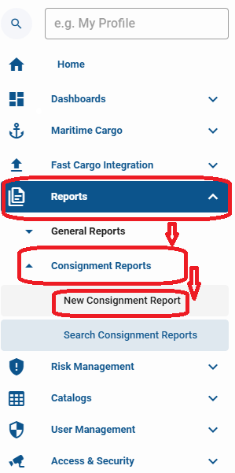

Fill below fields

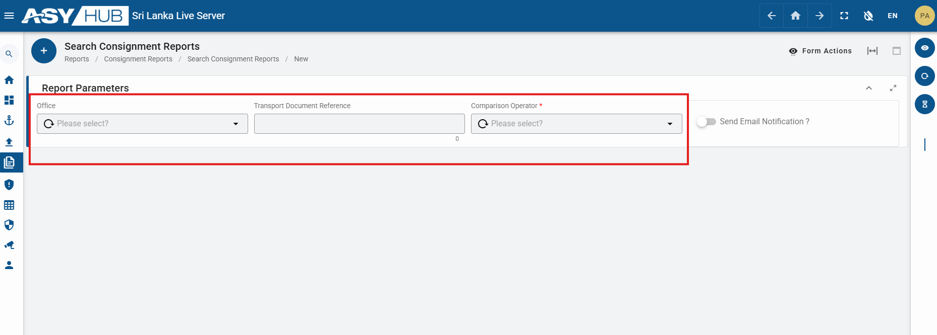

After filling the relevant data Form Actions -- Submit

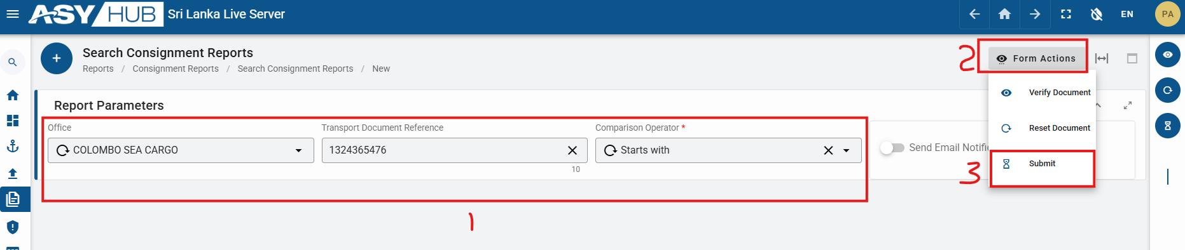

After successfully submission – next – Search Consignment Reports

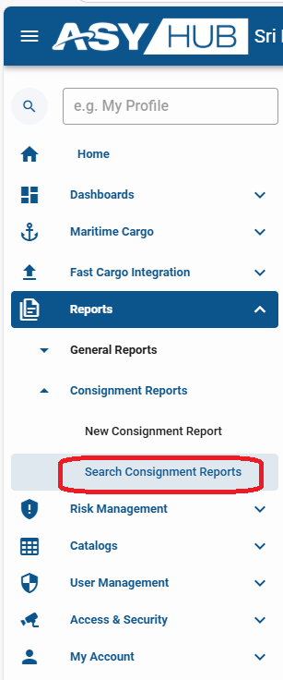

Then below results will appear

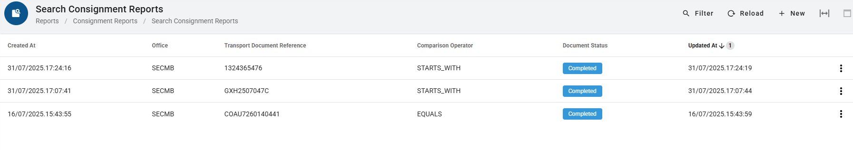

To View below results—click on view

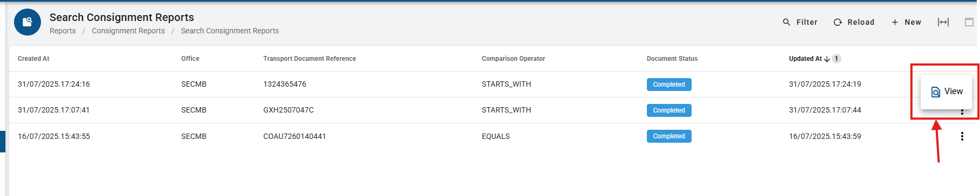

Then the below window will appear

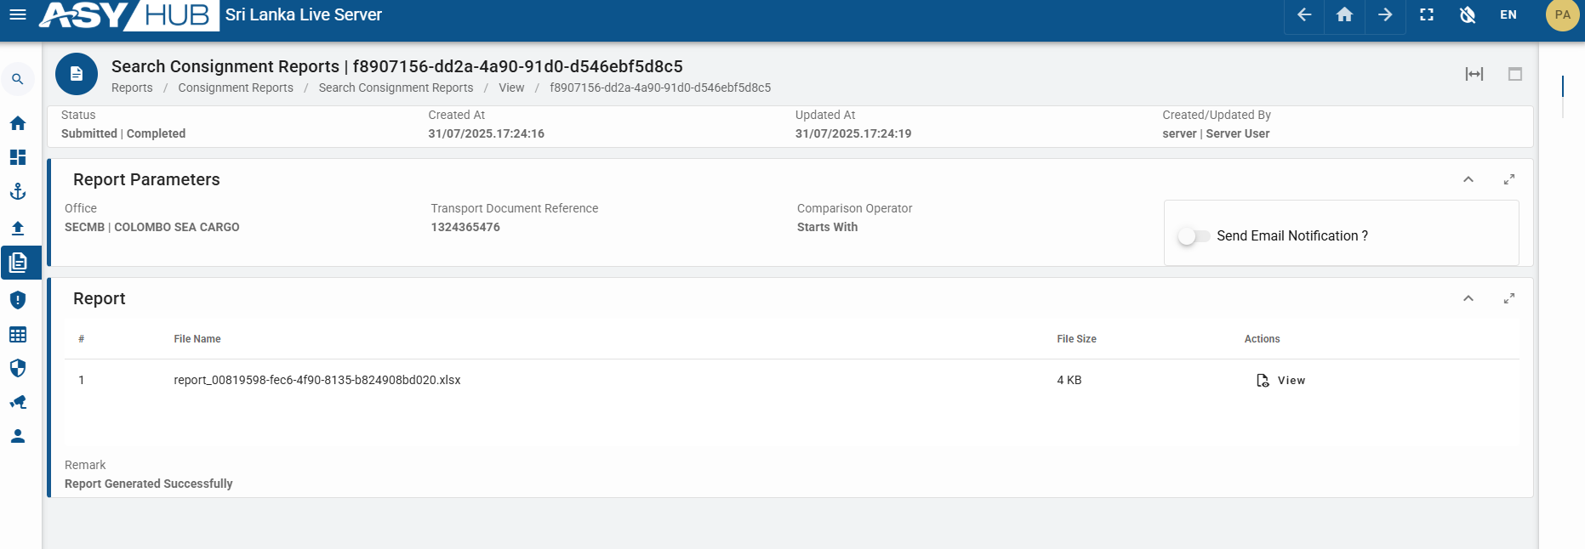

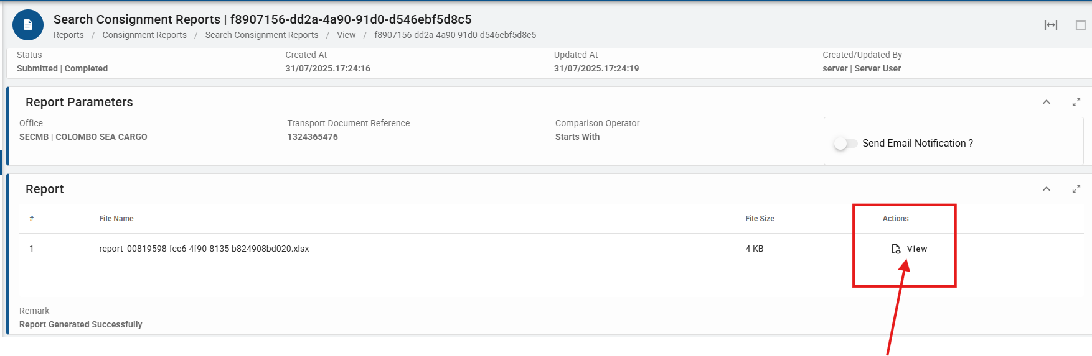

By clicking View Action

Excel report will be downloaded



The report will be consisting of below fields

